Air Filtration: Technology
3M's Filtration Products Division approach to air filtration is simple: efficient particle removal without sacrificing airflow rate. This approach has yielded a line of highly efficient, low-pressure drop air filtration media and filters.

In many applications, particles larger than 10 microns drop out of the air stream before reaching the filter due to gravitational settling. Particles less than 10 microns are those, which are of most concern to human health and damage to sensitive equipment. Our products use several filtration mechanisms to remove these smaller particles from the air. The following capture mechanisms are present:

Sieving: Large particles are too large to pass between the fibers of the filter.
Inertial impaction: Larger particles collide with the filter fibers because due to the high inertia they cannot follow the air stream as it moves around the fibers.
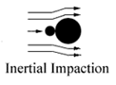
Direct interception: Intermediate-sized particles are captured as they follow the air stream around the filter fibers; active whenever the air stream comes within a half particle diameter of the fiber.
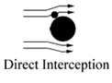
Brownian diffusion: Particles smaller than 0.1 micron are carried by the motion of the air molecules, causing the particles to randomly come into contact with the filter fibers.
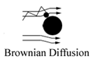
Electrostatic enhancement: Fibers are given permanent electrical charges to attract particles in their vicinity, which greatly increases the “electret” filter’s ability to capture small- or medium-sized particles.
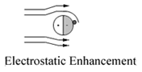
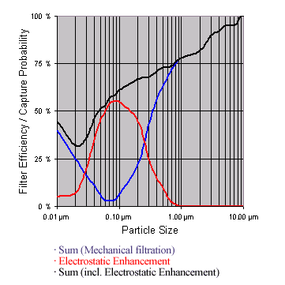
With only mechanical filtration mechanisms active (sieving, inertial impaction, direct interception, Brownian diffusion) filter efficiency dips sharply in the sub-micron range, as shown by the blue line in the figure below. To compensate for this dip in filtration performance without adding pressure drop, the fibers are given an electrostatic charge (red line). These filtration mechanisms together result in a total filtration performance, which is shown by the black line.
3M Innovation To Make A Better Filter
A prime example of electrostatic enhancement in action is our FiltreteTM Split fiber filtration media. Each nonconductive fiber contains permanent, electrostatic charges that enhance particle capture efficiency. With its patented electret construction, Filtrate media captures particles throughout the media, rather than on the media surface.
The result is filter systems with demonstrated high efficiency against difficult-to-capture, sub micron particles. It is best designed for use when high efficiency is needed with low-pressure drop. Because we have created electrostatic fibers that are so efficient in capturing particles, we are also able to give FiltreteTM media a more open construction. Air molecules encounter fewer fibers as they pass through the filter, resulting in extraordinarily low-pressure drops and greater airflow.
The low-pressure drop is maintained during use because FiltreteTM Split fibers filtration media is a three-dimensional, depth-loading filter rather than a surface-loading filter. Although the use of electrostatics is not uncommon in filtration, the FiltreteTM charged filtration media is superior for three reasons:
- The highest charge density of any electrostatically charged material;
- Permanently charged rectangular fibers that provide more loading surface than round fibers;
- Charged media combined with depth filtration to provide a higher loading capacity.
http://cms.3m.com/cms/GB/en/2-47/leFlEA/view.jhtml

